AGENDA

REGULAR MEETING

YECA GOVERNING BOARD

Yolo Emergency Communications Agency, 35 N. Cottonwood Street, Woodland, CA 95695

November 7, 2018

3:00 P.M. Public Session

ALL ITEMS ARE FOR ACTION UNLESS OTHERWISE NOTED WITH AN ASTERISK (*)

- Call to Order (3:00 PM)

- Public Comment *
Speakers must state their name and city of residence for the record and limit their remarks to three minutes. Members of the public audience may address the Governing Board on any item not on today’s agenda. No response is required and no action can be taken, however, the Governing Board may add the item to the agenda of a future meeting.

- Announcements
a. Dave Hetland received the 2018 Northern CA APCO “Communications Line Supervisor of the Year Award”

- Approval of the Agenda

- Consent Agenda
Consent Agenda items are considered to be routine and will be considered for adoption by one motion. There will be no separate discussion of these items unless a member of the Governing Board, member of the audience, or staff requests that the Governing Board remove an item. If an item is removed, it will be discussed in the order in which it appears on the Agenda.

- Approval of the Minutes from the August 1, 2018, Regular Meeting
- Operations Division Report
- Current Year Budget Status Update
- Administration Holiday Closure Schedule
- FY18 Surplus List of Items
f. Quarterly Law & Fire Call Statistics Report

- Old Business – Information Only
  - General discussion and current status update of YECA building
- Law Call Priority Project List Review – *Voted Item
  - Staff summary outlining a list of recommended priority changes
  - Law Call Priority Matrix
- Radio Project Update – Information Only
  - Staff summary report outlining the details of various radio project updates

- Bylaws & Board Review Update – Information Only
  - Board summary providing an administrative review of Board duties

- Text-to-911 Project Update – Information Only
  - Board summary detailing the status update for Text-to-911 implementation

- Next Scheduled JPA Board Meeting TBD

- Items for Future Agenda
  - FirstNet Presentation
  - FY18 External Audit Presentation

- Adjournment
I declare under penalty of perjury that the foregoing agenda was available for public review and posted on/or before November 2, 2018 on the bulletin board outside of the Yolo County, Erwin Meier Administration Center, 625 Court St., Woodland, California and on the agency website:
http://www.yolo911.org/board-meetings
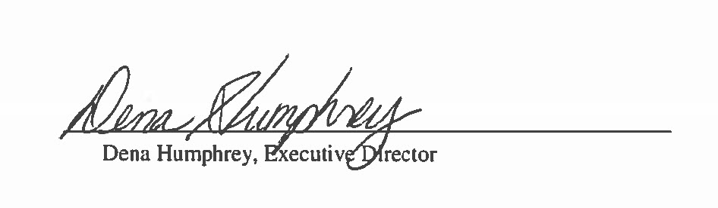
**The meeting room is wheelchair accessible and disabled parking is available. If you are a person with a disability and you need disability related accommodations to attend the meeting, please contact Corina Macias at (530) 666-8919 or (530) 666-8909 (fax). Requests for accommodations must be made at least two full business days before the start of the meeting. **

